|  |  |
| --- | --- |
| How to | D:\projecten\1210326 MDBA ROWS (local, See N)\C. Report - advise\Workshops\2015-02 workshop 3 UAT, end user training\Screenshots\DELTARES_ENABLING_RGB.pngSource - Prepare Flow forecast data for Source RO |
| Description | D:\Software_delft-fews (local, See P)\Marketing\Icons (FEWS_logo_icon)\Delf-FEWS-256x256.pngCreate short term forecast and combine with observed and outlook |
| Comments | Please be aware that the screenshots may deviate slightly from the application |
| version | 2016-01 |

Flow forecasts (tributary inflows) are location based time series, created by merging 3 types of data:

* Observations (OPO)
* Short term forecast, with user defined source selection in modifier display from:
  + BoM Streamflow fcst (imported as supplied by BoM)
  + Manual forecast (created with modifiers in modifier display, seeb elow):
    - Trend / Recess
    - Pulse
  + Source forecast (i.e. forecast from yesterday)
* Long term forecast: Seasonal pattern, select scenario from 50 / 75/ 90 and min.   
  Note: All 4 scenarios are exported.

Note: there is no automatic smooth transition between the short and long term forecast.

To create the short term forecast:

1. Complete the OPO observed Flow for all locations (elsewhere in Workflows display)
2. Select the type for each location in the Modifiers display
3. Select the parameters for the manual forecast as required
   1. Pulse: forecast will start from the observation at T0, pulse to the defined *Peak Q* (must be higher then obs), with the defined *Rise rate* (defined as <1, next value is 1/(Rise rate) \* previous value) and then will remain at the *Peak Q* value until *Peak timing* days after T0, from when it will recede with *Recede rate* (defined as <1, next value is Recede rate \* previous value) to the *Target* value. Manual forecast will be cut of (just before) target values reached).
   2. Trend: forecast will start from the observation at T0, trend to the defined *Target* (must be lower then obs), with the defined *Recede rate* (defined as <1, next value is Recede rate \* previous value) and then will remain at the *Target* value. Manual forecast will be cut of (just before) target values reached).
4. 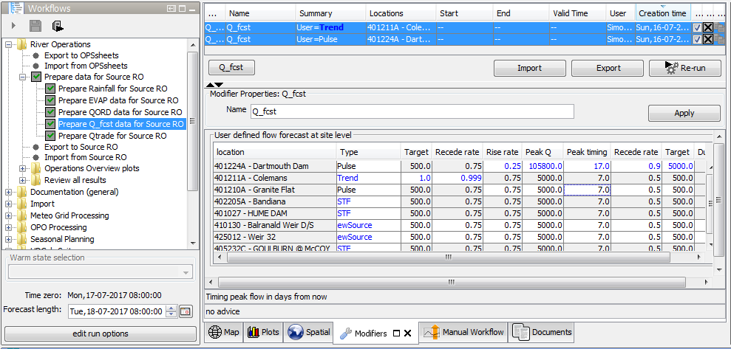*Apply* and *Re-run*

3

1

2